Lab Objective

* Install and configure Remote Access Role

**Lab Procedures**

**1.** Log in to Server01 as the **Contoso\administrator** user account. The Server Manager console opens.

**2.** On Server Manager, click Manage and click Add Roles and Features. The Add Roles and Feature Wizard opens.

**3.** On the Before you begin page, click Next.

**4.** Select *Role-based or feature-based installation* and then click Next.

**5.** On the Select destination server page, click Next.

**6.** Scroll down and select Remote Access.

**7.** When the Add Roles and Features Wizard dialog box opens, click Add Features.

**8.** Back on the Select server roles page, click Next. On the Select features page, click Next.

**9.** On the Remote Access page, click Next. On the Select role services page, keep DirectAccess and VPN (RAS) selected and select Routing. Click Next.

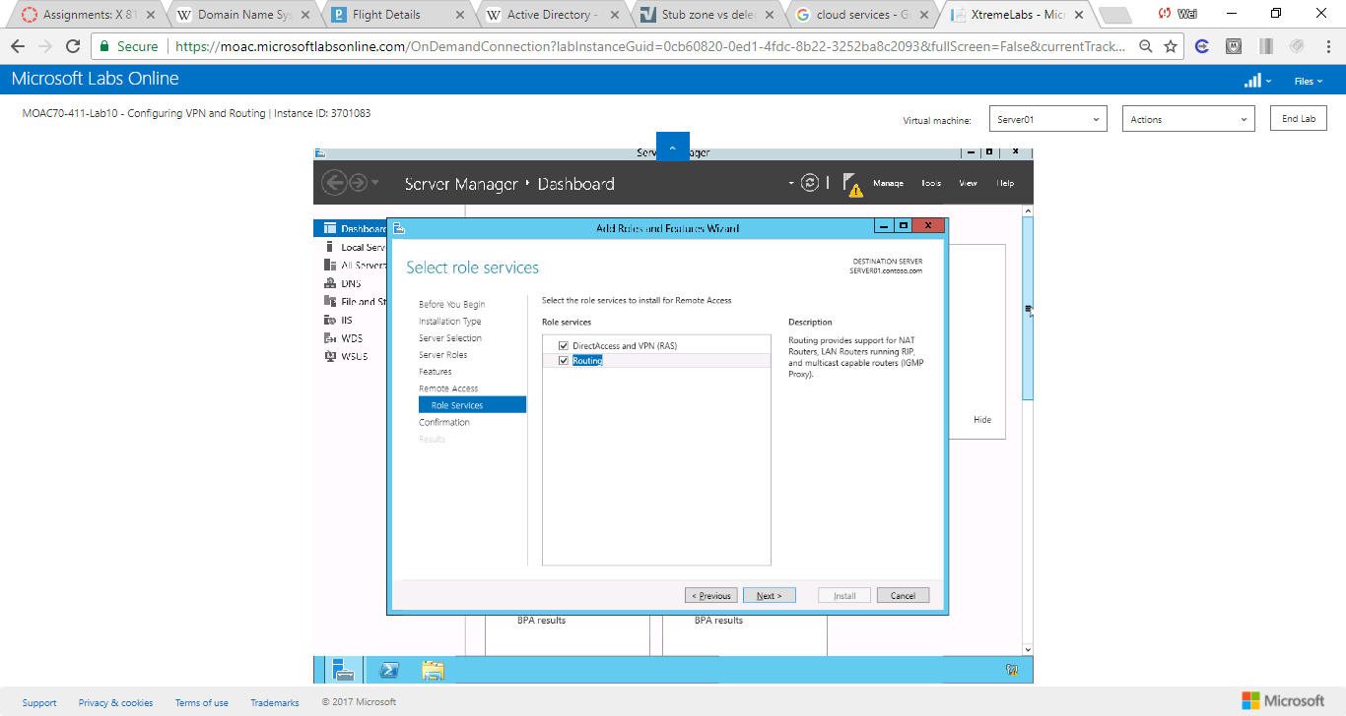

Figure 1 On the Remote Access page, click Next. On the Select role services page, keep Direct Access and VPN (RAS) selected and select Routing. Click Next

**10.** On the Confirm installation selections page, click Install.

**11.** When the installation is complete, click Close

**Lab Summary**

To configure standard VPN connections, I used Routing and Remote Access Server. I installed Routing and Remote Access Server on Server01. During this lab, I installed and configured Routing and Remote Access Server. Routing and Remote Access Service (RRAS) is a Microsoft API and server software. It allows applications developed to administer the routing and remote access service capabilities of the operating system, to function as a network router. Developers can also use RRAS to implement routing protocols.